Project Valentine**MSG**

Lead Developer: ShortHorizon451

GitHub: <https://www.github.com/shorthorizon451>

Done with FMV – Endeavour

Date of Release: Tuesday, February 13, 2023 8:00 PM GMT + 08:00

Programming Languages: Hypertext Markup Language (HTML), Visual Basic Scripting (VBScript),

Windows Programming/Programming CMD

Operating Systems: Windows NT Family (Windows XP, Vista, 7, 8, 8.1, 10, 11)

Successor: bmicalc

GitHub Repository: <https://www.github.com/bmicalc>

Note:

This program is a demonstration of Microsoft’s HTML Application (1999, Internet Explorer 5), and Batch File Automation. The production of the application was supposedly will take place with Microsoft Small Basic, but due to technical issues, it was being done with mixed programming languages. Recovery of an HTA file from FMV-Discovery could take a very long time to recover due to not having proper equipment in order to recover the source code.

Program Background:

It started when I started to revisit FMV-Discovery’s achievements, I eventually discovered my old Facebook post just approximately a week prior to the event.

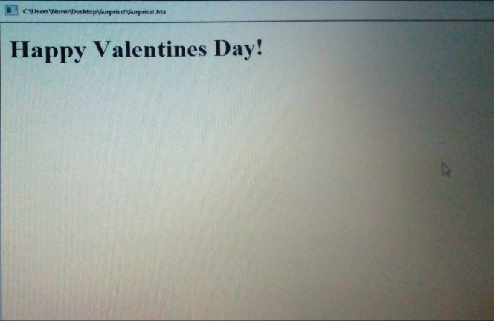<!DOCTYPE html>

<html lang="en">

<head>

    <HTA:APPLICATION

        APPLICATIONNAME = "Surprise!.hta"

    />

</head>

<body>

    <h1>Happy Valentines Day!</h1>

</body>

</html>

Figure 1: Source Code

Figure 2: Output from February 2022 Photo

Now, it is now roughly 4 days to rewrite the code. Now, in order for it to work, We need to use roughly two or three programming languages for it to work. I might need to ditch VBScript to save space on HDD and I do no longer have documentations on the language, which means I might need to re-study the entire language. Plus the 4 day gap wouldn’t be enough. Using Batch and HTML would be more efficient due to Windows’ Interpreter for these languages.

End

Start HTA

Start CMD

Start

Thanks for reading this!